**RESUME**

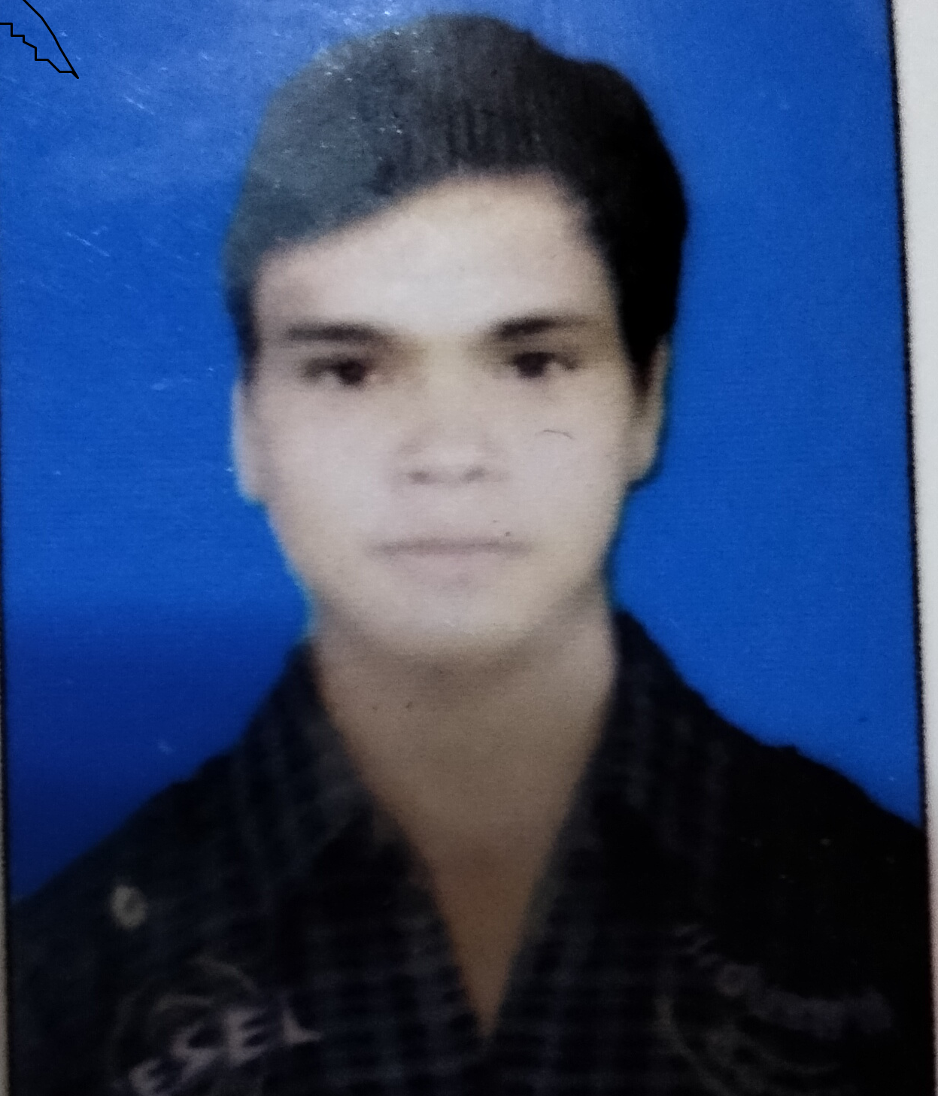

**Manish Raghav**

**Contact No.** :- 7037808991

**E-mail:-** manishraghav95964@gmail.com

**CAREER OBJECTIVE**

To work in a firm as a Software Engineer .I can utilize and apply my knowledge, skills which would enable me grow while fulfilling organizational goals.

B**ASIC ACADEMIC CREDENTIALS**

|  |  |  |  |  |
| --- | --- | --- | --- | --- |
| **Qualification** | **Board** | **College/School** | **Year** | **Percentage** |
| MCA | Chandigarh University | Chandigarh University | 2020-2022 | **-----------** |
| BCA | Sanskriti University | Sanskriti University | 2017-2020 | 6.27 CGPA |
| 12th | UP Board | Government Inter College | 2015 | 72% |

**Technical Proficiency**

* Microsoft Office Word, Microsoft Office Excel;
* Programming Language ---- C++ , JAVA, Android, Firebase , python, (HTML,CSS, JavaScript);

**Working on my OwnProject**

* **ROOMSLINK(Android, FireBase) -** RoomsLink in that project I am Solving RealLife Problem , This project will help the person who does not know anyone in the new city and wants to rent a Room.

**INTERPERSONAL SKILLS**

* Ability to rapidly build relationship and set up trust.
* Confident and Determined
* Hard working with Smartness

**PERSONAL DETAILS**

Father’s Name : Mr. Shivcharan Singh

Date of Birth : 15th July 1996

Gender : Male

Place : MATHURA

Nationality : Indian

Marital Status : Unmarried

Language Known : Hindi & English

Hobbies : playing cricket;

Like to : competitive Programming (java)

**DECLARATIONS**

*I do here by declare that all the information given above is true and best of my knowledge and belief.*

**( Manish Raghav)**